Frequently Asked Questions
1. Who is sponsoring this project? The project is mainly sponsored by the USDA (Natural Resource Conservation Service and Agricultural Research Service), with contributions from various other public and private partners.
2. Who does the project aim to benefit? The project will enhance the development of a tool that goes by the acronym “SHAPE”. This tool benchmarks soil health measurements across US soils and agricultural management practices. The main outcome of the tool is to help farmers, ranchers, and landowners interested in knowing the status of soil health on their fields and the potential to increase soil health and crop productivity. The tool will be freely available online and as a smartphone app.
3. Will my data and personally identifiable information be protected? The identity of participants will be protected. Your soil health data from your fields is used in developing the SHAPE tool. However, the precise location of your fields, your responses to the management questions, and your personal contact information will not be shared unless you explicitly give your permission to do so.
4. How do I enroll? You will sign up through an online calendar program, selecting a date and time that best works for you. This signup sets up a Zoom meeting survey with you and a SHAPE project facilitator. During the meeting the facilitator will share their screen and walk you through the process. It is crucial you are using the Zoom video feature and can see the screen of the facilitator. During the enrollment you will be responding to questions about how your fields have been managed over the past decade. These are basic questions such as tillage, crop types, rotation, manure/cover crop/grazing practices (if any), etc. Typically the survey is for only 2 or 3 fields, based on farm size. The survey typically takes about 30 minutes or less.
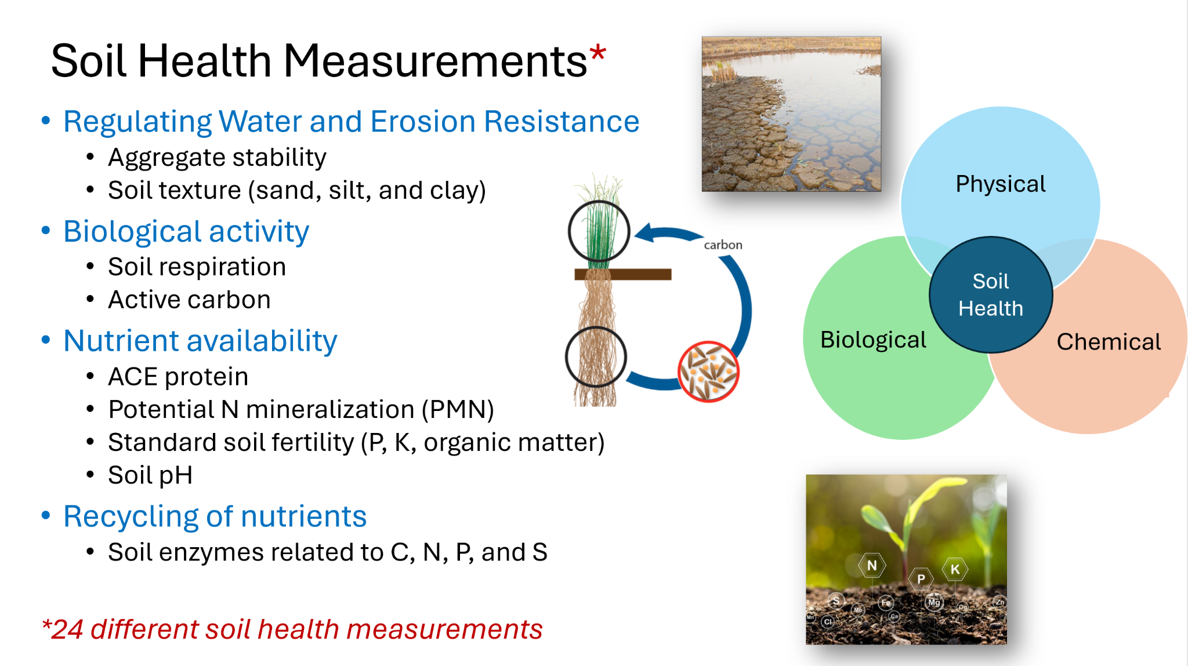
5. How does the soil sample collection work? Usually within 3-6 months after the management survey a soil-sample team will come to your area and hand-sample 2 or 3 locations within each field you enrolled. This time frame may be longer when an area has only a few fields ready for sampling. Locations within a field are based on predominant soil types within the field. Within days the samples are delivered to the lab for processing and analysis. The soil sample team will be in communication with you a few days prior to arriving at your fields.
6. What soil health measurements are being tested? The plan is for 24 soil health tests for each sampling location (i.e. 2-3 per field). See figure for soil health categories and example analyses. All of your soil health data will be shared with you when it is ready. Since some of these tests are time-consuming and thousands of samples are being processed at the same time on this project, results could take months.
7. When will I see the soil health results from my fields? Results from your fields will be shared in batches, as they are completed, using the SHAPE tool to help interpret the results. A final report will be given to you at the conclusion showing all the results, after the SHAPE tool has been improved using the entire project dataset.
8. When will the improved SHAPE tool be made available for all farmers? The plan is to release the enhanced SHAPE tool in 2029 when all the data has been analyzed and the tool has been modified.
9. What are the deadlines for participating as a farmer/landowner? There are a certain number of fields allocated to each state. Once those spots have been filled, we will not seek any new applications from those states. Please sign up early to ensure you have a spot. Most states have space for at least 80-100 fields. States that are largely agricultural will typically have between 150 and 250 fields.

